

Asset Practice Questions: Science

**1. Rajan wants to re-use the water that he used for washing some fruits and vegetables. For which of these activities should he use it?**

**A.** Cooking

**B.** Drinking

**C.** Washing clothes

**D.** Watering plants

**2. Red, amber, and green are the colours in a traffic light. Sometimes we see amber alone flashing. What does this indicate?**

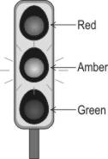

**A.** Stop completely.

**B.** Go without halting.

**C.** Go in one direction only.

**D.** Stop or proceed with care.

**3. The blindfolded student shown here was given a packet containing a few objects. He identified them as a long stick, a ball kind of thing, a soft object and a sharp object.**

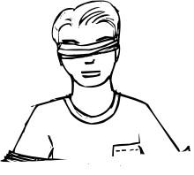

**Which of the senses did he use to identify the objects?**

**A.** Sight

**B.** Hearing

**C.** Smell

**D.** Touch

**4. Malaria is a disease that is spread by mosquitoes. Mosquitoes lay eggs in stagnant water. Which of the following methods would help to control the number of mosquitoes?**

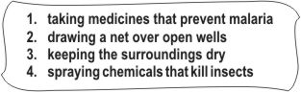

**A.** Only 1

**B.** Only 2 and 3

**C.** 1, 2 and 3

**D.** 2, 3 and 4

**5. Kumar was eating tomatoes, green beans and cucumbers. Which part of the plant was he eating?**

**A.** Roots **B.** Stems **C.** Leaves **D.** Fruits

**6. You are given four bags for your shopping. Which of these bags is bad for the environment?**

**A.** Leather bag

**B.** Plastic bag

**C.** Jute bag

**D.** Cloth bag

**7. Which of these would be the time taken by the Earth to turn once on its own axis?**

**A.** A day

**B.** A week **C.** A month

**D.** A year

**8. Kevin falls down in the playground and scratches his knee badly. He needs to do some things to treat the wound. Which of the following should he do FIRST to treat it properly?**

**A.** Apply medicine over the area.

**B.** Put a bandage to cover the wound.

**C.** Wash the area gently with clean warm water.

**D.** Rub salt over the area to protect it from germs.

**9. Binit saw a man blowing bubbles using a loop and some soap-water. This is how the loop looked.**

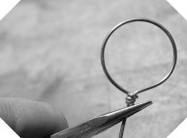

**It was made of a material that could be bent and would remain in this shape after being tied up. Which of the following objects can be used to make such a loop?**

**A.** A chalk stick

**B.** A cotton string

**C.** A plastic straw

**D.** A wooden pencil

**10. Samir looked out of the glass window of a train in the afternoon. He could see a man standing outside on a bridge. He could see everything else that was on the other side of the glass window too.**

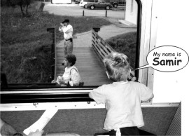

**Which other object allows things on the other side to be seen through it, like the glass window? A.** A bright torch

**B.** A clean mirror

**C.** A polished plate

**D.** A pair of spectacles

**11. When we breathe in air, our lungs swell up and grow bigger in size. When we breathe out air, our lungs return to their original size. To allow this to happen, the lungs should be .**

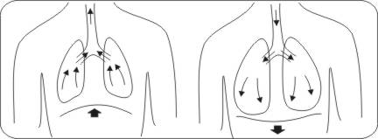

**A.** stiff and hard

**B.** made up of bones

**C.** spongy and elastic

**D.** shaped like a bean

**12. If Razia was blindfolded, which sense organ would be necessary to find out whether a substance is warm or cool?**

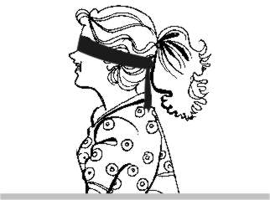

**A.** Skin

**B.** Ears

**C.** Nose

**D.** Eyes